Deliverable 3

3. Strategy Pattern
3.1 Case 1 – Item Search
Problem
The system allows users to search for lost and found items using different criteria such as item name, category, and location.
Implementing all search behaviors directly inside one controller or service using multiple if/else conditions would make the code complex, difficult to maintain, and hard to extend.
As new search criteria are added, the logic would grow significantly, leading to poor readability and violation of design principles such as the Open/Closed Principle.

Solution
The Strategy Pattern separates search behavior into independent strategy classes.
A common interface SearchStrategy defines the search operation, while concrete strategies such as:
- SearchByNameStrategy
- SearchByCategoryStrategy
- SearchByLocationStrategy
implement different search algorithms.
The SearchContext class holds a reference to a SearchStrategy and delegates the search operation to the selected strategy at runtime based on user input.

Justification
The Strategy Pattern is appropriate because:
- It encapsulates different search algorithms into separate classes
- New search criteria can be added without modifying existing code
- It eliminates complex conditional logic (if/else)
- It allows dynamic selection of search behavior at runtime
- It follows the Open/Closed Principle and improves maintainability

UML Diagram
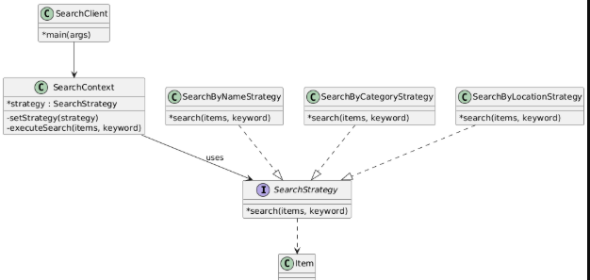

3.2 Case 2 – Claim Processing
Problem
The system allows officers to process student claims in different ways depending on the situation.
Some claims require strict verification, some can be processed quickly, and others require manual handling.
Implementing all claim-processing logic directly inside the controller using multiple conditional statements would tightly couple the controller to business logic, making the system harder to maintain and extend.

Solution
The Strategy Pattern separates claim-processing behavior into interchangeable strategy classes.
A common interface ClaimStrategy defines the claim-processing operation, while concrete strategies such as:
- StrictClaimStrategy
- FastClaimStrategy
- ManualClaimStrategy
implement different processing behaviors.
The ClaimContext class holds a reference to a ClaimStrategy and delegates the processing operation to the selected strategy at runtime based on the officer’s choice.

Justification
The Strategy Pattern is suitable because:
- It encapsulates different claim-processing algorithms into separate classes
- New processing strategies can be added without modifying existing logic
- It allows officers to select processing behavior dynamically
- It simplifies controller logic and improves separation of concerns
- It follows the Open/Closed Principle and enhances flexibility

UML Diagram

